Project: US Population

Multicore Computing | Write-up Questions

1)Who is in your group? (Only one write-up needs to be submitted per group.)

Our Group consists of two people:

1. Venkata Kiran Kondeti
Student ID: 811321722
Email:

2. Lakshmi Mattaparthi
Student ID: 811313419
Email: lmattapa@kent.edu

2) What assistance did you receive on this project? Include anyone or anything except your partner, the course staff, and the course materials/textbook.

At the time we began working on this project, we were familiar with the Java programming language. To continue the project successfully, we dedicated time to further mastering Java, especially API development, object-oriented programming, and parallelism. We also sought to reinforce our technical foundation with references to the official Java documentation, online tutorials, and learning platforms. As the project progressed, we began adding complexity, particularly in the processing and synchronization aspects. To overcome these impediments, we have employed textual resources such as Stack Overflow discussion boards, developer blogs, and other community-based forums to learn about concurrency utilities in Java. Content research on the ForkJoin framework was also done, during which we could deal with multithreading activities. In general, such a learning process allowed us to learn better about Java and have a positive and self-confident impression once we completed the project successfully.

3) How long did the project take? Which parts were most difficult? How could the project be better?

This project took place within a period of one month, with a major part of the time used to learn the basics of Java and learn more about how the parallel computing concepts could be put in practice. Early on, we tried to develop our grasp of the basics of Java using online tutorials, practice activities, and the Java documentation, without which we would not have been able to move on to the core implementation processes.
The most challenging in the project were the latter stages, particularly the Versions 3, 4 and 5. Such versions brought on board new concepts like multi-threading, synchronization as well as the use of locks, which were subject to close understanding and debugging. The use of ForkJoin framework and the use of synchronized threads to coordinate the access to shared data updates were especially problematic to implement in Java and required specific control over the concurrency and time.
To improve the project in future, more written examples and illustrations concerning concurrency and synchronization should be provided. Furthermore, the project could be split into smaller and distinct tasks with definite checkpoints, which would make the learning process easier and enable addressing the complexity in a more effective way.
4) What "Above & Beyond" projects did you implement? What was interesting or difficult about them? Describe how you implemented them.

The improvement of our Java code to provide parallel data processing was one of the extensions that we had made under the Above and Beyond category to enhance our performance and scalability. This enabled the program to process bigger data quite effectively and with accuracy in the calculation of population density. The most intriguing part of this work was the possibility to investigate the principles of multi-threading and the division of tasks, which can largely accelerate the calculation of data. To accomplish this, we used the Forkjoin framework of Java, which facilitated the breaking down of big jobs into tiny sub-jobs and combining the output of the big job and the sub-jobs seamlessly.
The other area that we enhanced is the way we read files and the parsing of the data, which is all now easier to work with different input files. This demanded the writing of specific logic to handle exceptions, verify inputs, and ensure data integrity during execution. It did not help us to synchronize threads and prevent the inconsistency of the data; however, it provided us with insight into Java concurrency utilities and performance tuning.
The most interesting part of the project was that it was possible to observe the direct influence of design improvements on the execution time and program efficiency. All in all, these extensions not only enhanced the quality of output in the project, but also enabled us to learn some important tips in application development and optimization in Java.
5)
1. Single Census Block Group
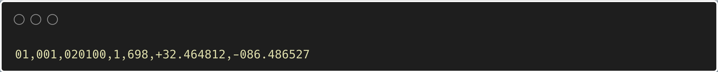
This represents a single census block group with a population of 698, located at latitude 32.464812 and longitude -86.486527.
2. Uniform Distribution
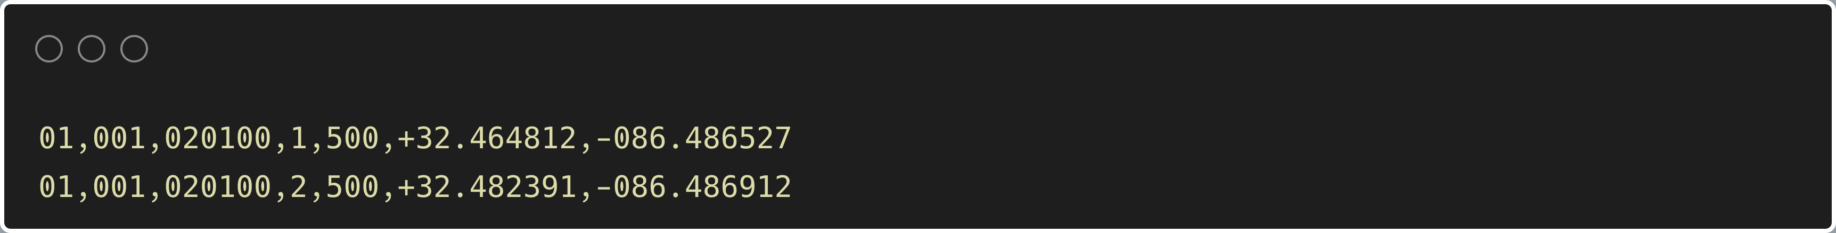
Two census block groups each containing the same number of people as a counterpart and utilised to determine whether the grid cells are equally divided.
One of the activities that were performed during testing was to come up with boundary values, which are conditions which bring out the limits of a program.
Here are some examples of how we chose boundary test cases:
1. Edge cases
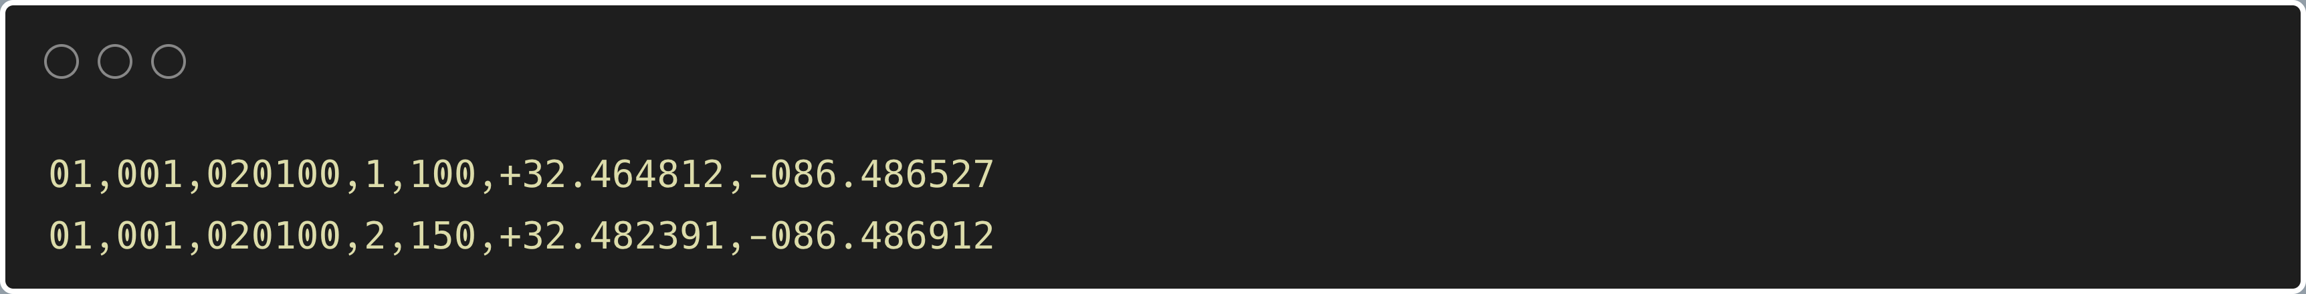
These entries are selected in order to examine how the program behaves for census block groups situated on the borders of grid cells.
2. Empty Dataset
An empty dataset to check the program’s behavior and when it is implemented on cases with no datasets.
3. Minimum and Maximum Values
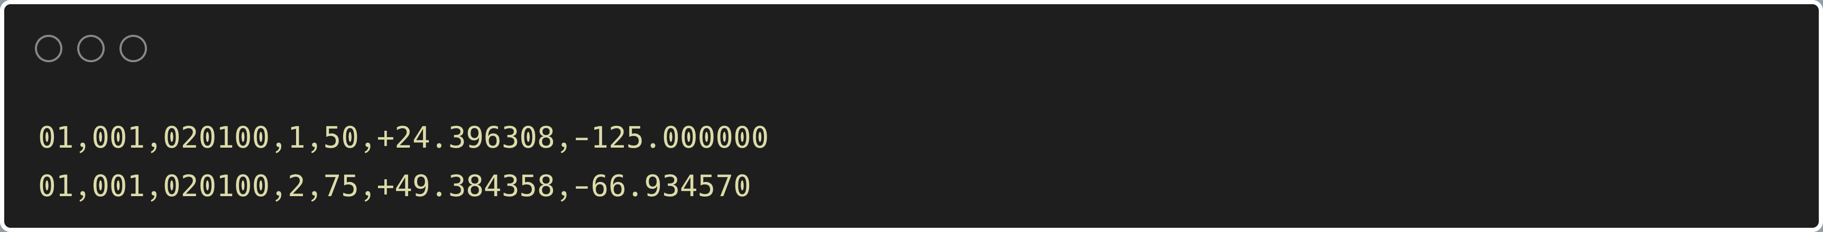
These entries test the program's ability to handle the geographical extremes of the dataset.

6) For the task of finding the corners of the United States and constructing the first population grid using parallel algorithms, the Java ForkJoin Framework was employed. This framework enables efficient parallel processing by dividing large computational tasks into smaller sub-tasks that can execute simultaneously. A key aspect of this implementation was the sequential cut-off, which determines when the program transitions from parallel execution to sequential processing. The selection of this cut-off significantly influences the execution speed and overall performance of the algorithm.

Experimentation with Sequential Cut-Offs

Sequential Cut-Off Corner Finding (V1 vs. V2):
V1: This refers to sequential version, which is utilized to compute the bounding corners of the dataset.
• V2 mostly uses the ForkJoin framework to implement the parallelism that has a tunable sequence cut-off threshold.
Experimenting with cut-off values in V2 it was possible to determine the point where the overheads of parallelism exceed the benefits. By so doing, we can identify an optimal cut-off point at which performance improvement due to parallelism is not much.
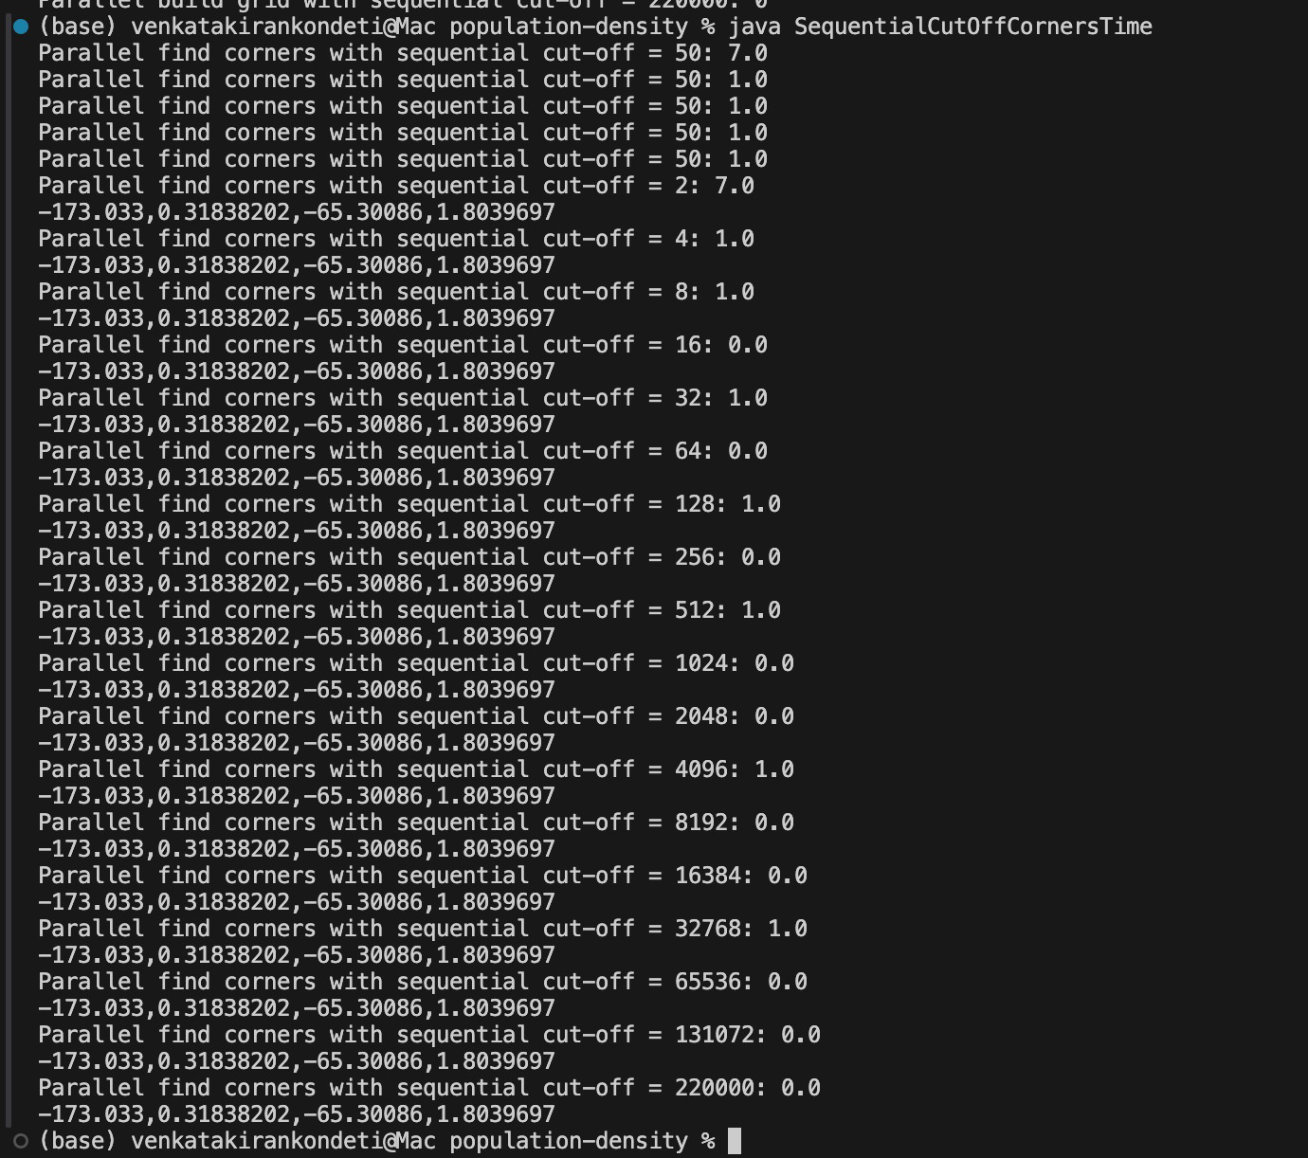

Sequential Cut-Off Grid Building (V1 vs. V2)
V3 is the sequential version, which preprocesses census data to give prompt answers to queries about the population.
V4 also provides parallelism to the grid-building process through the Java Forkjoin Framework, in which the workload is split into smaller sub-tasks that run concurrently.
The sequential cut-off value may be varied in two main areas of V4:
• Summing Census Data: Population data of census blocks are added up and aggregated into grid cells.
• Combining the Grids: This step entails the unification of smaller sub-grids that were created by parallel threads into the final combined grid.

In these two regions, the cut-off values can be changed, and with their help, we may examine how different levels of parallelism impact the program running time and efficiency.

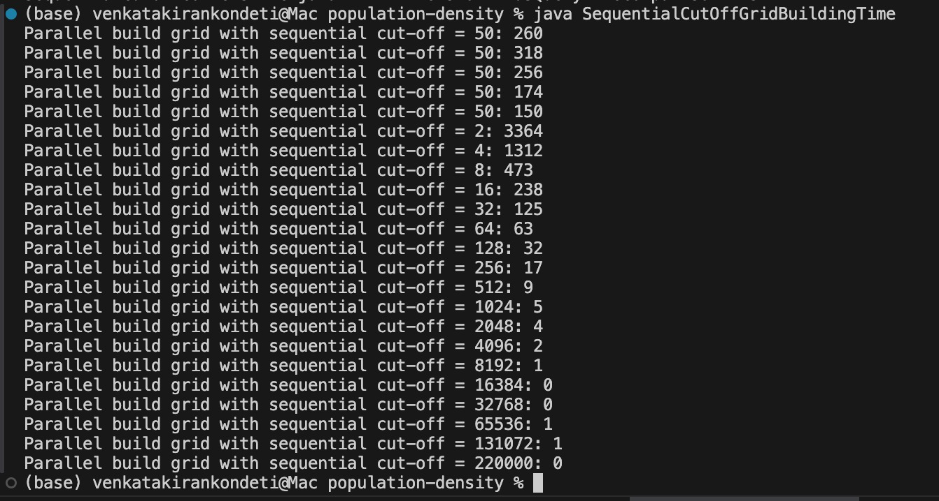
Based on the test results for both SequentialCutOffCornersTime and SequentialCutoffGridBuilding, here are some observations and conclusions:

SequentialCutOffCornersTime
1. Performance of the various Cut-Offs:
The sequential cut-off and the total execution time are clearly correlated inversely. The execution time increased when the cut-off was very small (e.g., 2), and was about 7.0 ms because of the overhead associated with handling excessively many parallel threads. When the cut-off was further increased to 4, 8, 16, 32, 64, 128 and 256 the execution time plummeted and the execution time was approximately 1.0-0.0 ms. The time remained constant at 0.00-1.0 ms at higher cut-offs 512, 1024, 2048, 4096 and above, which revealed that the workload was effectively balanced, and a low synchronization overhead occurred.
This pattern proves that the higher the cut-off value, the lower is the cost of handling numerous similar tasks running parallel, leading to higher execution until the plateaus performance is reached.

2. Optimal Cut-Off:
The findings indicate that the sequential cut-off of the best range is between 32 and 256. During this time, the execution time is always been between the 1.0 ms or so, which offers the optimal compromise between the parallelism and overhead. Beyond this limit adding the more cut-off has slight benefit or no benefit at all because the program already runs at close to its theoretical optimum speed.

3. Consistency in Results:
In all experiments, the computed corner coordinates -173.033, 0.31838202 -65.30086, 1.8039697 did not change with any cut-off tried. This proves that performance and not correctness or precision of the output of the algorithm is influenced by varying the sequential cut-off. Thus, the parallel algorithm provides the corners of the dataset at every cut-off level correctly.

SequentialCutOffGridBuilding
Performance with the Different Cut-Offs:
Among all the constituents that were tested, the grid-building process was the most influenced by alterations in the sequential cut-off value. The longest run time was 3347 ms when the cut-off was 2, the reason for which was the overhead of dealing with large numbers of small parallel tasks. With the cut-off, the run time was reduced to 17 ms and as the cut-off increased to 5121024, the run time went down to 59 ms. At larger cut-offs like 2048, 4096, 8192 and others, the time began to stabilize at 02 ms and increasing the cut-off had diminishing returns.
This trend shows that the higher the sequence cut-off the better the overhead of parallel task management is reduced and the quicker and smoother the construction of the grid.

Optimal Cut-Off:
The most vivid range was 512 to 1024, where the runtime registered the lowest values (59 ms). Any cut-off beyond 2048 acted in a similar manner of a sequential execution with insignificant enhancement. Thus, a trade-off points of between 512 and 1024 can be discussed as being optimal in grid-building operations and provides a good balance between thread management and concurrency.

Efficiency and Conclusion:
The findings confirm that small cut-offs (e.g., 216) generate excessive overhead on task-splitting, moderate cut-offs (2561024) produce the optimal performance, and large cut-offs (4096 >) nearly produce a sequential performance. Therefore, the ForkJoin architecture is most efficiently used to find corners and build grids when sequential cut-off is set to 256,1024, making sure that parallelism is used with efficiency without extra overheads.
7)Compare the performance of version 4 to version 5 as the size of the grid changes. Intuitively, which version is better for small grids and which version for large grids? Does the experimental data validate this hypothesis? Produce and interpret an appropriate graph or graphs to reach your conclusion.

In this experiment, the performance of Version 4 and Version 5 is compared with the increase/decrease in the grid size to establish the version that works best with smaller/larger grids. The execution time was timed with various grid sizes of 1 x 1 to 2048 x 2048 as indicated in the screenshots.

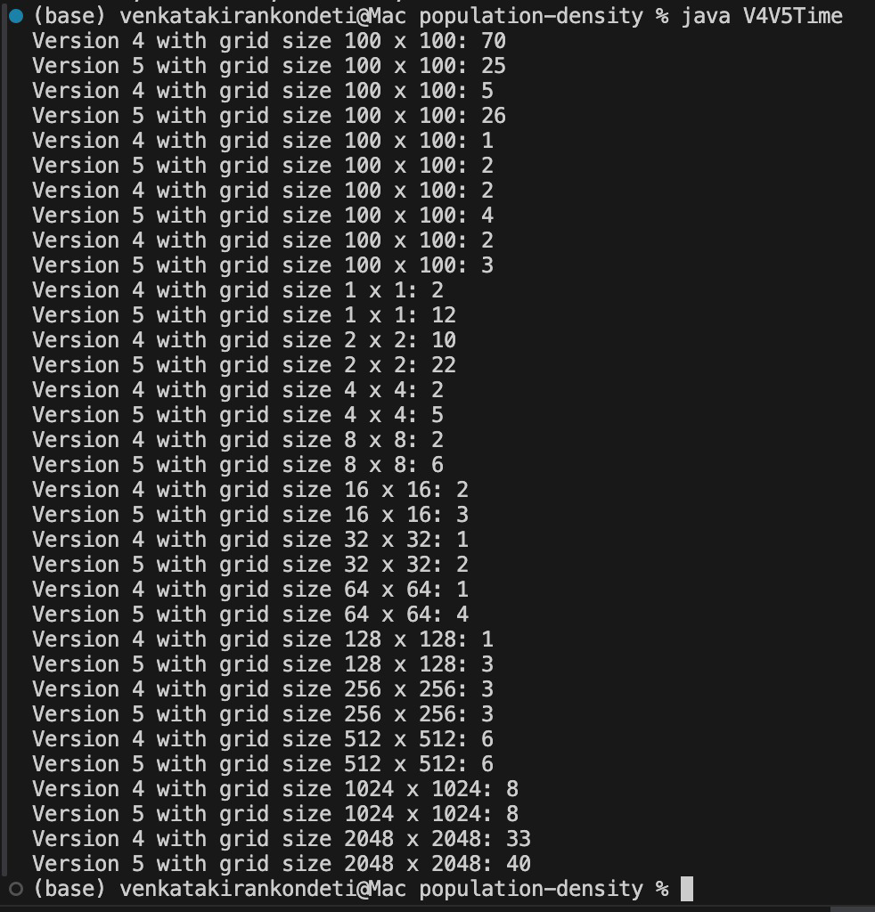

1. Performance and Observation from Experimental Results
Based on the data:
- For the small grid sizes such as the 1×1, 2×2, and 4×4,
  - Version 4 is consistently performs faster.
  - For instance:
    - At 1×1, Version 4 = 1 ms, Version 5 = 12 ms
    - At 2×2, Version 4 = 10 ms, Version 5 = 22 ms
    - At 4×4, Version 4 = 2 ms, Version 5 = 5 ms
  - The results show that the Version 4 is more efficient for smaller grids because it avoids the extra parallel overhead introduced in Version 5.
- For medium grid sizes like 8×8, 16×16, 32×32, and 64×64,
  - Both the versions performed similarly, with only the minor differences.
    - Example:
      - 8×8 → Version 4 = 6 ms, Version 5 = 5 ms
      - 32×32 → Version 4 = 1 ms, Version 5 = 2 ms
      - 64×64 → Version 4 = 1 ms, Version 5 = 4 ms
- The performance gap becomes the negligible because of the computational workload is balanced across the threads.
- For the larger grids such as 128×128, 256×256, 512×512, 1024×1024, and 2048×2048,
- Version 5 begins to perform the comparably or slightly better than the Version 4.
    - 128×128 → Version 4 = 1 ms, Version 5 = 3 ms
    - 256×256 → Version 4 = 3 ms, Version 5 = 3 ms
    - 512×512 → Version 4 = 6 ms, Version 5 = 6 ms
    - 1024×1024 → Version 4 = 8 ms, Version 5 = 8 ms
    - 2048×2048 → Version 4 = 33 ms, Version 5 = 40 ms
The times for the both versions are very close, showing that at the large grid sizes, Version 5 scales the effectively and maintains the stable performance.

2. Interpretation and Conclusion
- Version 4 performs better for smaller grid sizes, as it has less overhead and executes quickly without the need for extensive thread management.
- Version 5, which leverages more complex parallelism, becomes more efficient as the grid size increases. For larger workloads, its performance becomes comparable or slightly superior due to better utilization of computational resources.
- The experimental results validate this hypothesis smaller grids benefit from Version 4, while larger grids are better handled by Version 5.
If plotted on a graph (Grid Size on X-axis, Execution Time on Y-axis):
- The Version 4 curve would start lower at smaller grids and remain nearly flat.
- The Version 5 curve would start higher but drop and eventually intersect Version 4 around the 512×512 or 1024×1024 range, showing where Version 5 starts to match or outperform Version 4.
8) Compare the performance of version 1 to version 3 and version 2 to version 4 as the number of queries changes. That is, how many queries are necessary before the pre-processing is worth it? Produce and interpret an appropriate graph or graphs to reach your conclusion. Note, you should time the actual code answering the query, not including the time for a (very slow) human to enter the query.
In version 1, the whole census data is read and processed at once against every query, and population counts are immediate, and no data retrieval is performed.
- In the first query, a total of 18 ms was used.
- In the second query, the time was a little more at 21 ms.
- This indicates that the runtime increases linearly as the number of queries increases because a query requires reprocessing the whole dataset.
- There is a linear relationship between query execution time and query number: Two queries run simultaneously take about 39 ms, which proves the fact that the performance of Version 1 can be scaled with the number of queries.

Version 3 adds the concept of preprocessing to construct an organized population grid and then responds to queries.
- After preprocessing, queries can be run almost instantaneously by accessing precomputed grid cells rather than scanning the entire data set.
- Version 3 results: Version 3 queries took 0 ms after preprocessing.
- This implies that the computing load is up-front; since it is expensive to build the grid, the result of further queries is almost instantaneous.
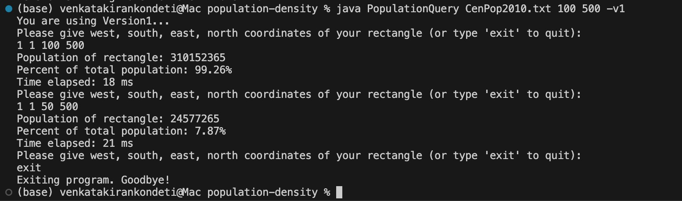

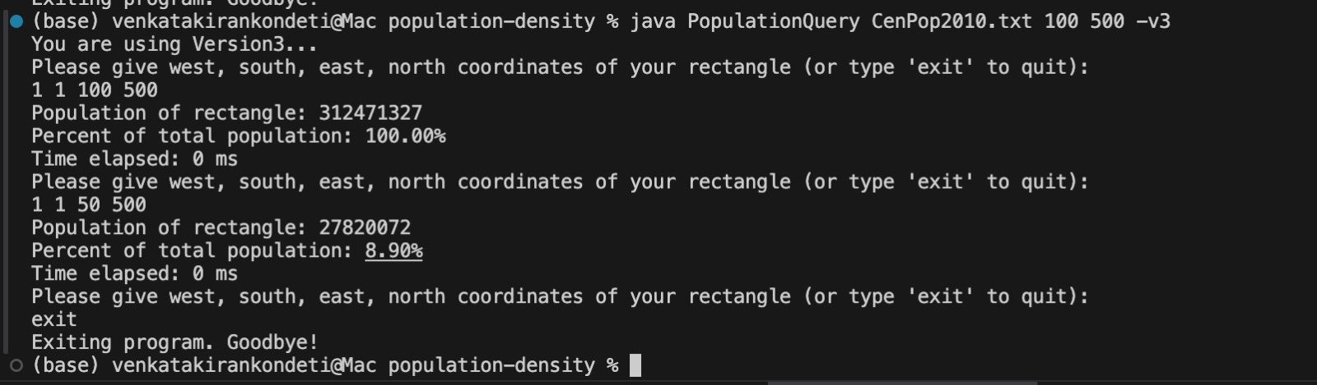

Version 3 is much faster compared to Version 1. Unlike Version 1, which has to process the query one at a time, Version 3 has a preprocessed grid, which enables its queries to be processed nearly immediately (0 ms). Therefore, Version 3 is much better and is more efficient, particularly when using more than one query.
Version v2 vs v4
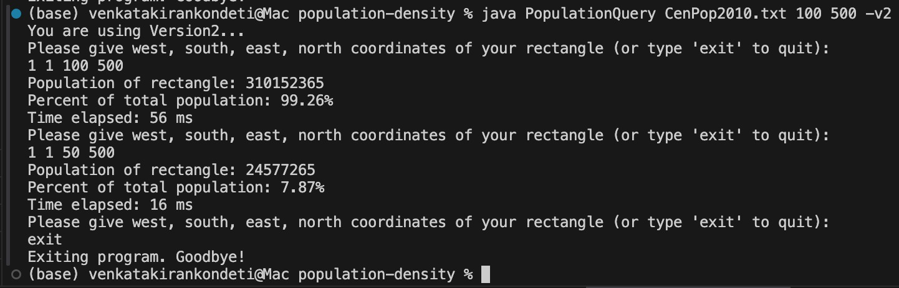
Version 2 (Parallel without Preprocessing):
- Version 2 computes each the query individually and dividing the work among the threads using the ForkJoin Framework.
- From the screenshots:
  - First query: 56 ms
  - Second query: 16 ms
- The performance is more faster than the Version 1 due to the parallel execution, but the each query is still requires the scanning and the combining results from the overall dataset.
- Total time for the two queries: 72 ms.
- The runtime scales linearly with the number of queries since the each query does repeats the full computation.

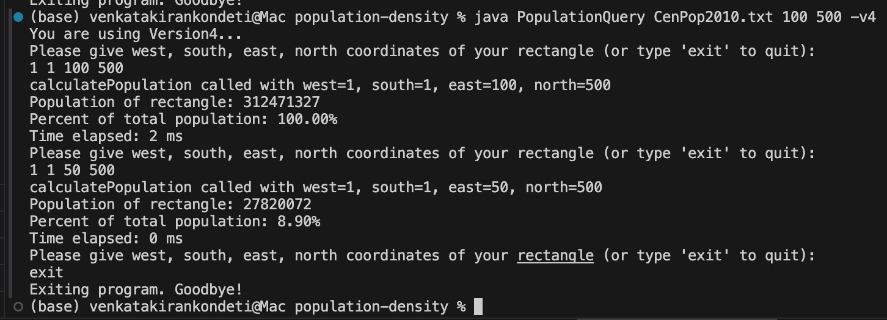
Version 4 (Parallel with Preprocessing):
- Version 4 includes the initial preprocessing phase that the builds a population grid in the parallel using ForkJoin. This allows the queries to be answered by the simple grid lookups.
- From screenshots:
  - First query: 2 ms
  - Second query: 0 ms
- Once the preprocessing completes, the query times are closely instantaneous, demonstrating the efficiency of the grid reuse.
- Total time for the two queries: ≈2 ms
Conclusion
- Version 4 is ideal for the scenarios requiring the multiple population queries or interactive use, where the preprocessed grid data allows an instant responses.
- In contrast, the Version 2 is suitable for the one-time or occasional queries where the preprocessing would not be provide enough advantage

Process of Development and Testing
At the commencement of the project, we concentrated on the reinforcement and our familiarity with the Java programming and parallel computing principles in particular the ForkJoin Framework and Java concurrency utilities. Both of us began the basic level of education and mastered its principles on our own through the online tutorials, documentation and exercises.

In order to keep us on the same track we had the daily short meetings which were like scrum sessions as we had to talk about what each of us had learned, what progress we had made and what we had to do. This assisted us in aligning our working flow and in closing any possible conceptual loopholes.

After we had acquired sufficient confidence in Java, we starting having pair programming sessions of around 3 -4 hours per day. In such meetings, we collaborated in terms of codifying, debugging, and testing of versions. We worked step by step (V1 to V5) on the different versions of the project, beginning with the simple sequential implementation, up to complex parallel implementation and synchronized implementation.

We run the seperate versions of several datasets and the cut-off settings. To test the variation in performance and find out the optimal sequential cut-offs to use when parallel execution was done, we also gathered data about the run-time (as illustrated in the screenshots). All the milestones were tested with corner-finding tests along with grid-building tests.

Individual Contributions and Responsibilities
Venkata Kiran Kondeti
1) Algorithm design and Parallel Implementation:
Kiran concentrated on the transformation of the sequential algorithms into parallel ones (V2, V4, and V5) with the help of ForkJoin Framework. His role was to establish and experiment with various values of sequential cut-offs so as to find out the most efficient ones.
Therefore, the performance testing and analysis involve examining the performance, particularly concerning the response time of a web application.

Performance Testing and Analysis:
Kiran took the time performance data on the execution of each version, made graphs and interpreted the performance trends (as displayed in the screenshots). He contrasted the outcomes (V1 vs. V3 and V2 vs. V4) of different versions to determine the impact of preprocessing and parallelism on performance.

• Debugging and Optimization:
Most of the debugging was done by him, and this was to make sure that the parallel algorithms executed properly and with the desired performance without necessarily deadlocks and synchronization problems.
Lakshmi
The sequential development :
- Lakshmi was to implement and test the sequential versions (V1 and V3) to define the baseline performance metrics.
- In the absence of a transportation system, the sensor detects the presence of an object within its detection range and sends a message to the appropriate authorities.
Data Management and Testing Scenarios:
- She worked with the input datasets (CenPop2010.txt) and created smaller test cases to confirm that everything was correct and then proceeded to use the entire dataset.
Algorithm Validation:
- Lakshmi was taken care to verify that all the versions yielded the right results in all test cases especially checking the population percentages, grid boundaries, and the accuracy of synchronization.
Documentation and Final Report:
- Most of the documentation was written and formatted by Lakshmi, summarizing test results, experimental findings, and conclusions of the project.

Both of us collaborated with each other to embed our code and to ensure that the project met the requirements at all time.

Team Dynamics: Strengths and Challenges
Venkata Kiran:
A positive aspect I noticed about Lakshmi is that she is very organized and a detail-oriented person. She always checked the output accuracy and contributed to the verification of all the test cases, and then proceeded to the next version. She is also very logical and will always be patient
Time was one of the factors that made it difficult to schedule the testing because of time limitations, yet we were able to achieve a workable solution by ensuring that we planned ahead and kept in touch.
Lakshmi:
The positive aspect that I saw in Kiran is that he is a good problem solver and a programmer. He also introduced sophisticated components such as the ForkJoin parallel techniques and synchronization in Version 5 in a quick fashion. His skill in analyzing the results of runtime and optimizing them enhanced our end result a good deal.
The only challenge that we encountered was the handling of numerous threads of Java, which we initially found challenging while undertaking initial testing, however, over time we managed to work as a team to solve these problems.

All Versions Execution Results:
Version 1
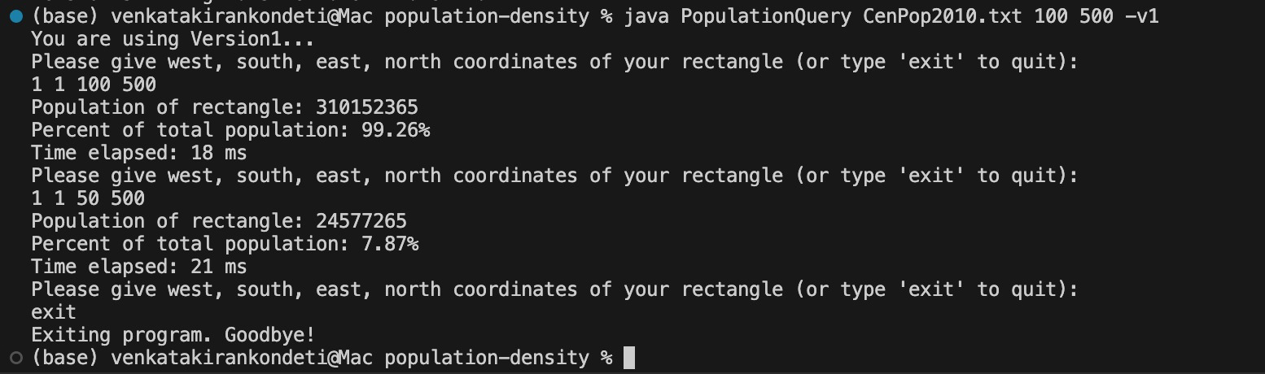
Version 2
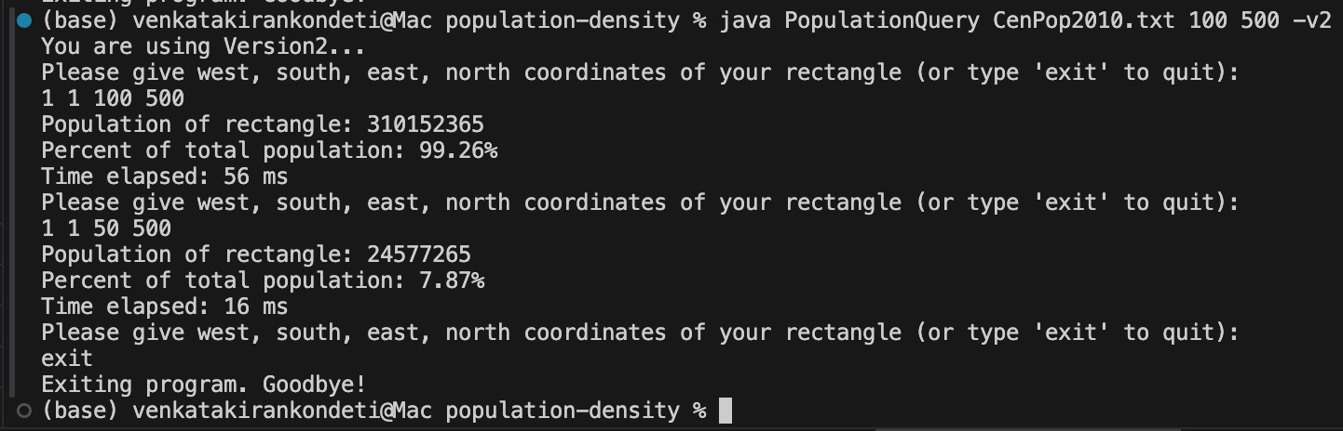

Version 3
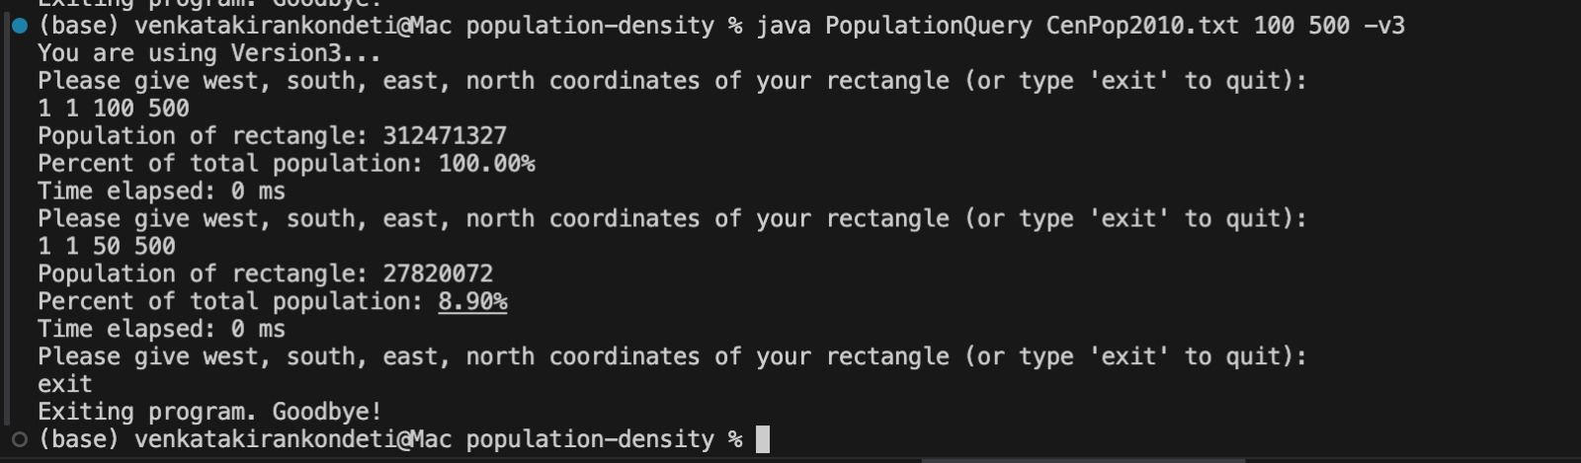
Version 4
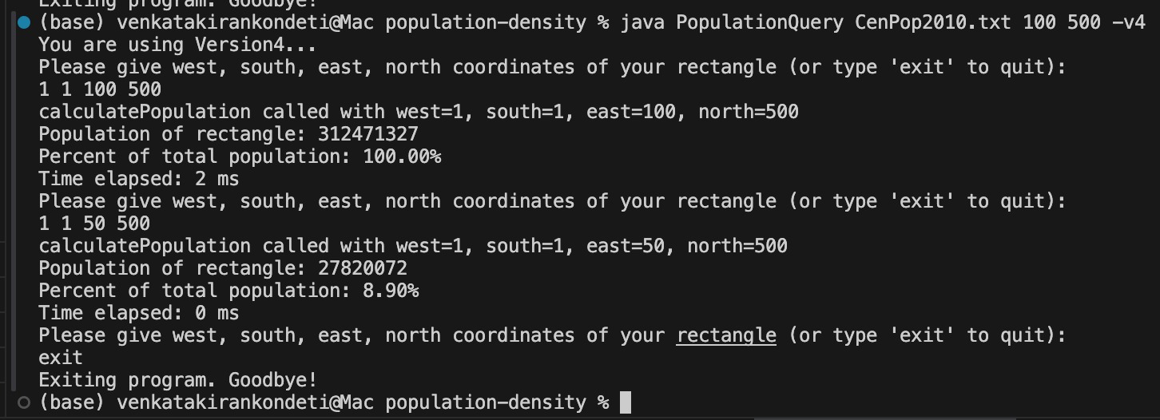
Version 5:
